Building a Product Recommendation System
for a Greek Online Toy Shop
Graph Embeddings, Content Similarity and Text Signals on Sparse Retail Baskets
Papamanoli Ioanna f2822510
Sevastou Maria f2822512
Table of Contents
Abstract 4
1. Introduction 5
1.1 Our Project 5
1.2 Our Vision and Goals 5
2. Methodology 6
2.1 Data Collection 6
2.2 Dataset Overview 6
2.3 Data Processing, Annotation and Normalization 7
Validation and text preparation 7
Annotation strategy 7
Basket construction 8
Co-purchase normalization 8
Time normalization 8
2.4 Algorithms, NLP Architectures and Systems 8
FP-Growth 8
Co-purchase graph 9
Node2vec random walks 9
Skip-Gram with negative sampling 9
TF-IDF over Greek product names 10
Adamic-Adar link prediction 10
Metadata similarity and the heterogeneous graph 10
System 10
3. Experiments. Setup and Configuration 10
3.1 Chronological split 10
3.2 Evaluation task 11
3.3 Controlled model selection 11
3.4 Selected configuration 11
3.5 Metrics 12
4. Results and Quantitative Analysis 12
4.1 Initial two-model comparison 12
4.2 Development ablation 13
4.3 Product-page evaluation 14
4.4 One-time test result 14
4.5 Segment analysis 15
4.6 Statistical stability 16
4.7 Graph visualization 16
5. Qualitative and Error Analysis 17
5.1 Successful patterns 17
5.2 Failure patterns 18
5.3 What the errors imply 18
6. Discussion, Comments and Future Work 18
6.1 Interpretation 18
6.2 Limitations 18
6.3 Future work 19
6.4 Conclusion 19
7. Members and Roles 19
8. Time Plan 19
9. Bibliography 21
10. Appendices 22

Abstract
This report describes a product recommendation system built entirely from local data for a Greek online toy shop. Starting from a WooCommerce order export covering April 2019 to June 2026, we construct a co-purchase graph over 6,257 products, learn distributed product representations with a from-scratch Node2vec and Skip-Gram implementation. Behavioral evidence is then progressively combined with catalogue metadata and Greek product-name text.
The central finding concerns data rather than algorithms. Basket sparsity dominates everything else. Only 23.6% of orders contain more than one product. FP-Growth recovers exactly one frequent product pair from the entire history. Under these conditions purely behavioral signals saturate quickly. Adding content similarity, recency weighting and a heterogeneous graph raises development Hit Rate@10 from 0.303 to 0.395. A single frozen configuration evaluated once on held-out test data improves Hit Rate@10 from 0.293 to 0.373 over the earlier behavioral blend. On the product-page task, TF-IDF over Greek product names alone reaches 0.316 against 0.237 for the co-purchase graph, which we read as direct evidence that text compensates for missing interaction data.
All results carry wide bootstrap intervals because only 75 independent test queries exist. We report them as directional evidence rather than as established effect sizes.

1. Introduction
Online retailers with large catalogues face a navigation problem. A shopper who arrives at one product page has thousands of alternatives available in principle, but no practical way to discover the handful that are relevant. Recommendation systems close that gap by inferring relevance from prior behavior, from product attributes, or from both.
This project builds such a system for a real Greek toy retailer using nothing but the shop’s own order history. No external API, no third-party behavioral data and no pre-trained commercial model is used at any point. Every component is implemented directly in Python and NumPy, including frequent itemset mining, graph construction, random walks, Skip-Gram training, TF-IDF weighting and evaluation. The project depends on six packages in total.

1.1 Our Project
The input is a single Excel export from WooCommerce containing 14,178 order lines across 9,727 distinct orders and 6,257 distinct SKUs, spanning just over seven years. Each line records an order identifier, a timestamp, a status, a SKU, a product name together with a set of Greek catalogue attributes covering category, brand, recommended age, franchise and target gender.
From this we build four successive layers. The first is a market-basket layer that uses FP-Growth to identify products recurring together across orders. Above it sits a behavioral graph layer in which products become nodes while co-purchase within an order creates weighted edges. The third is a representation layer, where biased random walks over that graph are treated as sentences and fed to a Skip-Gram model with negative sampling so that every product receives a dense vector. The fourth is a content layer that combines structured catalogue attributes with TF-IDF similarity over Greek product names. These signals are combined into a single ranked recommendation list whose blend weights are selected on development data and then frozen before any test evaluation.

1.2 Our Vision and Goals
Our vision is a recommendation system that satisfies three demands at once. It should be genuinely useful to the shop, methodologically defensible as an academic project and simple enough to run on an ordinary laptop without external services. These pull against each other often enough that stating them together is worthwhile, because a system that scores well but cannot be inspected or deployed has solved the wrong problem.
The practical goal is a recommendation shelf that a shopper sees on a product page, answering the question of what else customers bought alongside the item currently in view. The research goal is narrower and more interesting. We wanted to establish how far behavioral signals can be pushed on genuinely sparse retail data and at what point content signals become necessary rather than merely helpful.
One distinction guided the design throughout. Products relate to one another in two different ways that require different evidence. Complements are items bought together, such as a construction set and the storage box that holds it. These surface naturally from co-purchase history. Substitutes are alternatives serving the same need, such as two construction sets from the same range. Purchase history rarely reveals them because customers usually buy one instead of the other. Catalogue metadata and product text capture substitutes precisely where behavioral data is silent, which is also where the sparse tail of the catalogue lives. The final hybrid carries both kinds of evidence so that the system stays behaviorally grounded while still representing rare products.
From this vision follows the concrete objectives of the project. We set out to discover recurring product combinations in order baskets and to build from them an interpretable product graph with normalized relationship strengths. On that graph we wanted to learn dense positional representations using an architecture borrowed from natural language processing, then integrate structured catalogue content without letting broad metadata categories form hubs that would overwhelm behavioral signals. Every algorithm was to be implemented from first principles so that each design choice remains inspectable rather than hidden inside a library call.
The evaluation objectives matter equally. We wanted to compare baselines and model variants on chronologically later orders, to investigate rare products and other error segments instead of reporting a single aggregate accuracy figure and to protect the final test set from repeated use during model selection. Underlying all of this was a commitment to quantify the structural limits imposed by basket sparsity rather than treating low scores as a modeling failure. The last objective was deployment, since a frozen model exposed through an inventory-aware interface demonstrates far more than a table of metrics does.
Some things are deliberately outside our scope. The system does not personalize by customer identity. It optimizes neither price, margin, stock levels, diversity nor conversion, because none of these signals exist in the analytical dataset. We record these as boundaries of the work rather than as hidden assumptions.

2. Methodology

2.1 Data Collection
The dataset is a private WooCommerce order export provided by the shop owner. It was generated directly from the store administration panel. No scraping, no external enrichment and no customer-level profiling is involved.
The raw workbook contains billing and shipping fields that identify customers. These are never loaded into the modeling pipeline. The workbook itself is excluded from version control. Only aggregated product-level artefacts are stored and reported. This matters both ethically and practically, since the recommendation task requires knowing which products appear together and never who bought them.
One deliberate decision concerns order status. The exports contain ten distinct statuses, heavily dominated by completed orders, as shown in Table 1.

Order status | Lines
wc-completed | 12,290
wc-cancelled | 625
wc-pickup | 481
wc-refunded | 405
wc-pending | 303
wc-ready-pickup | 46
wc-failed | 24
wc-processing | 2
trash | 1
wc-on-hold | 1
Table 1. Distribution of order lines by WooCommerce status.
We retain all statuses. A cancelled or failed order still expresses shopping intent, because the customer selected those products together whatever happened afterwards. Given how little multi-item data exists, discarding roughly 13% of lines would be costly. We did not assume this to be correct. Four status policies are compared empirically in Section 4. The all-status policy is kept because it wins on development data.

2.2 Dataset Overview
Table 2 gives the shape of the dataset after validation.

Property | Value
Order lines | 14,178
Distinct orders | 9,727
Distinct SKUs | 6,257
First order | 15 April 2019
Last order | 19 June 2026
Single-product orders | 7,436 (76.4%)
Multi-product orders | 2,291 (23.6%)
Mean distinct products per order | 1.46
Table 2. Dataset shape after validation.
The single most consequential number in this report is 23.6%. Only multi-product orders can generate a basket-completion query. Only they contribute edges to the co-purchase graph. Three quarters of the order history is silent for the purposes of collaborative signal. Every result that follows should be read against this constraint.
Catalogue completeness is uneven, which directly shapes how metadata is weighted. Table 3 shows how many products lack each attribute.

Content field | Missing products | Share of catalogue | Weight
Category | 0 | 0.0% | 0.35
Age | 1,026 | 16.4% | 0.25
Brand | 584 | 9.3% | 0.20
Hero / franchise | 4,746 | 75.9% | 0.15
Gender | 1,025 | 16.4% | 0.05
Product name | 0 | 0.0% | text channel
Table 3. Missing values per catalogue field across 6,257 products, with the metadata weight assigned to each.
Category is complete and receives the highest metadata weight. Hero is missing for three quarters of the catalogue and receives a low weight. It is excluded from similarity whenever absent rather than being treated as a shared unknown value. Treating absence as a shared value would wrongly make thousands of unrelated products appear similar. Product name carries no metadata weight because it feeds the separate text channel described in Section 2.4.

2.3 Data Processing, Annotation and Normalization

Validation and text preparation
The loader enforces the presence of order identifier, status and SKU, discarding rows that lack them. Greek text requires specific care. All string fields are HTML-unescaped, since exports contain entities where an ampersand was intended. Text is then normalized with Unicode NFKC, which reconciles visually identical but differently encoded characters. This is a common source of duplicate categories in Greek e-commerce data. Whitespace is collapsed. Textual null markers such as nan or n/a are converted to genuine missing values rather than being treated as content.
SKUs are kept as strings throughout, because several product codes contain leading zeroes that numeric parsing would silently destroy.

Annotation strategy
We use the existing catalogue attributes as weak structured annotations. We make no claim to have manually annotated anything for this experiment. The labels are treated as noisy. The same SKU can appear across many order lines with inconsistent attributes, so a single catalogue row is built per SKU by taking the most frequent non-null value for each field. This is deterministic and reproducible while acknowledging that the source metadata is imperfect.

Basket construction
Order lines are grouped by order identifier and duplicate SKUs within an order collapsed. A pair count therefore measures the number of orders containing both products and not the quantity purchased. Buying six copies of the same puzzle is one basket event rather than six. Every unordered pair inside a multi-item order contributes one unit of graph evidence.

Co-purchase normalization
Raw pair frequency is badly biased towards globally popular products. A bestseller co-occurs with everything simply because it appears everywhere. We therefore use a cosine-style association.
w(i, j) = c(i, j) / √( c(i) × c(j) )
Here c(i, j) is the number of baskets containing both products and c(i) the number containing product i. For ranking the direct neighbors of a seed product we additionally use directional confidence, given by c(i, j) divided by c(i). This answers the operationally relevant question of how often product j was present given that product i was seen.

Time normalization
A toy catalogue turns over quickly. Franchises rise and fall. A strong 2019 association may be meaningless in 2026. The selected model applies an exponential decay with a six-month half-life measured relative to the end of each training period, so recent baskets weigh more without discarding older evidence entirely. The decay reference point is the end of training, which means no development or test timestamp ever influences training weights.

2.4 Algorithms, NLP Architectures and Systems
This section describes each algorithm and, where relevant, its origin in natural language processing.

FP-Growth
FP-Growth mines frequent item sets without generating candidate sets, by compressing transactions into a prefix tree and mining that tree recursively. We implemented it from scratch and applied it to the full basket collection.
The outcome is itself a finding. At a minimum support threshold of 0.002, mining returns 35 frequent item sets. Thirty-four of them are single products and exactly one is a pair, namely SKU IT16951 together with IT16952, appearing in 21 orders. Classical market-basket analysis has almost nothing to work with here. This result motivated the entire subsequent direction of the project, because a model that cannot rely on frequent pairs must generalize beyond direct co-occurrence.
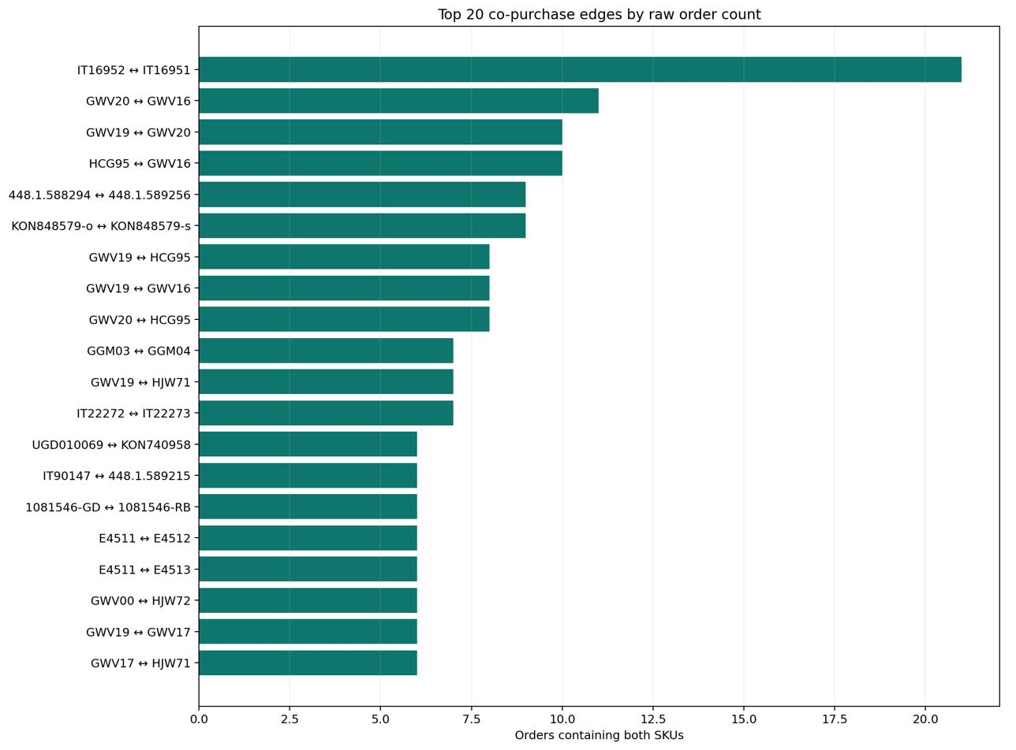
Figure 1. The twenty strongest co-purchase pairs by raw order count.

Co-purchase graph
Products become nodes and normalized co-purchase becomes weighted edges. Table 4 shows how sparse the resulting graph is.

Graph statistic | Value
Nodes | 6,257
Edges | 8,841
Density | 0.00045
Connected components | 2,637
Isolated nodes | 2,146
Largest component | 2,636 nodes
Mean degree | 2.83
Median degree | 1
Maximum degree | 65
Table 4. Structure of the co-purchase graph.
A median degree of one means the typical product has been co-purchased with exactly one other product in seven years. There are 2,146 products with no co-purchase edge at all, over a third of the catalogue. No purely behavioral method can reach them. The largest connected component covers 42% of the catalogue.
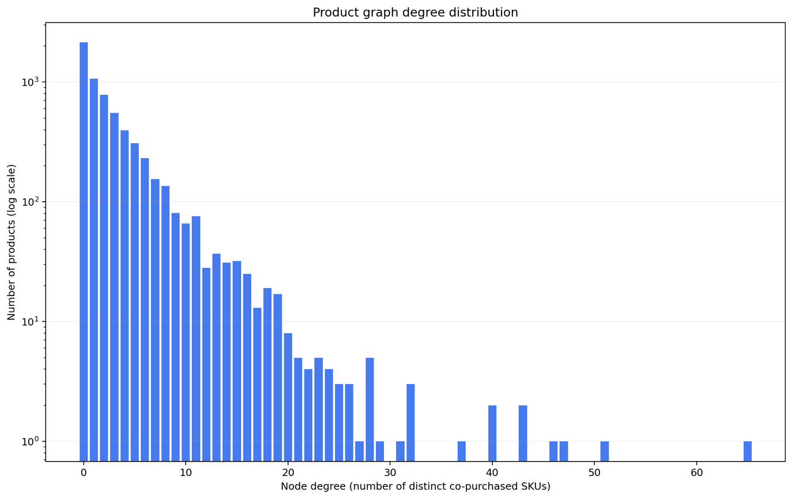
Figure 2. Degree distribution of the co-purchase graph, showing the heavy concentration at degree one.

Node2vec random walks
Node2vec generates node sequences by biased random walking. Two parameters control bias. The return parameter p discourages immediate backtracking, while the in-out parameter q interpolates between breadth-first exploration favoring structural equivalence and depth-first exploration favoring community structure. Our search selected p and q both equal to 1.0, which reduces to unbiased walking. This is unsurprising given that a graph with median degree of one offers very little structure for the bias to exploit.

Skip-Gram with negative sampling
This is where the project connects most directly to natural language processing. Skip-Gram with negative sampling was designed to learn word embeddings by predicting context words from a target word, approximating an expensive SoftMax with a small number of sampled negatives. We apply the architecture unchanged and substitute the domain, as Table 5 sets out.

Word2vec | Product2Vec (this work)
Sentence | Random walk over the co-purchase graph
Word | Product SKU
Linguistic context window | Nearby products in the walk
Distributional hypothesis | Products co-purchased in similar contexts are similar
Negative sampling | Negative products drawn by unigram frequency
Table 5. Correspondence between the word2vec formulation and our product setting.
The distributional hypothesis transfers cleanly. In language, words appearing in similar contexts have similar meanings. Here, products appearing in similar purchase contexts serve similar needs. The implementation is our own, written in NumPy, with 48-dimensional embeddings and cosine similarity for retrieval.

TF-IDF over Greek product names
The second explicitly linguistic component operates on the product names themselves. We build TF-IDF vectors over two channels. The word channel uses n-grams of length one to two and receives weight 0.60. The character channel uses n-grams of three to five and receives weight 0.40. Both channels are implemented from scratch, since the project uses no machine learning library.
The character channel is not decorative. Greek is morphologically rich. Product names mix Greek, English, brand names and numeric codes. Character n-grams capture stem-level similarity across inflected forms that word-level matching would miss entirely. They also degrade gracefully on transliterated or misspelled entries. As Section 4 shows, this component turned out to be one of the strongest single signals in the entire system.

Adamic-Adar link prediction
Adamic-Adar scores candidate links by summing the inverse log-degree of shared neighbors, so a rare shared neighbor counts for more than a popular one. We included it as a graph-theoretic complement to embeddings.

Metadata similarity and the heterogeneous graph
Structured attributes give a content-based channel that works for products with no purchase history at all, which directly addresses the 2,146 isolated nodes. Two products are scored by weighted agreement across category, brand, age, hero and gender, using the weights listed earlier in Table 3.
The heterogeneous graph extends this further by adding typed edges. Two products sharing a category, brand, age band or hero become connected even when they are never co-purchased. Random walks then traverse both behavioral and attribute edges, letting embeddings reach products that the co-purchase graph cannot see. Metadata edge weights are held at 0.05 against 1.0 for co-purchase, which prevents large categories forming hubs that would swamp genuine behavioral signal.

System
The final system exposes the frozen configuration through a Streamlit interface. The user selects a product, optionally uploads current stock so that recommendations are restricted to available items, filters by attribute and exports results as CSV. The codebase is packaged with console entry points and covered by 47-unit tests, all of which pass.

3. Experiments. Setup and Configuration

3.1 Chronological split
Orders are sorted by timestamp and assigned to splits without ever being broken apart. Table 6 gives the composition.
Split | Orders | Lines | SKUs | Multi-item | Period
Train | 6,808 | 10,310 | 4,797 | 1,810 | 2019-04-15 to 2024-07-13
Development | 1,459 | 1,995 | 1,164 | 265 | 2024-07-14 to 2025-08-21
Test | 1,460 | 1,873 | 1,035 | 216 | 2025-08-21 to 2026-06-19
Table 6. Chronological split of the order history.
A random line-level split would be substantially easier and substantially dishonest. It would let the model see part of a basket while predicting the rest of that same basket. It would also let future purchasing patterns inform predictions about the past. The chronological split asks the harder and more realistic question of what happens next given everything up to a point in time.

3.2 Evaluation task
The primary task is leave-one-out basket completion. For each eligible order one product is hidden using a fixed random seed while the remainder forms the query cart. The model must place the hidden product in its top ten. Each order contributes at most one query, so large baskets do not dominate the metric.
The export records no per-item cart timestamp, so this is not next-item sequence prediction. It measures set completion, which is the appropriate offline proxy for a shelf of items frequently bought together.
Because the deployed interface starts from a single viewed product rather than a full cart, we added a second and stricter protocol using exactly one seed SKU and one hidden target per order, with both required to exist in the training catalogue. This yields 76 development queries. Candidates recall@100 is reported alongside Hit Rate@10 to separate retrieval failures, where the target was never a candidate, from ranking failures, where it was retrieved but placed too low. That distinction turns out to matter considerably.

3.3 Controlled model selection
All selection happens on training and development data. The frozen configuration is written to JSON. A separate finalization command refits on train plus development and evaluates the test split exactly once, guarded by a sentinel file that prevents accidental repetition.
The following variants were compared.
- Four order-status policies.
- Ten graph-weighting variants covering cosine, Jaccard, lift and confidence, with pair-count thresholds of one to three.
- Six time-decay settings, comprising no decay and half-lives of 6, 12, 18, 24 and 36 months.
- Twenty Product2Vec configurations drawn by seeded random search.
- Eighty-five behavioral blend-weight combinations.
- Eighty-four four-signal blends including TF-IDF.
- Four heterogeneous metadata edge configurations.
Random search was preferred over grid search, following standard practice for hyperparameter optimization where a small number of parameters dominate performance. Candidates are ordered by Hit Rate@10, then MRR@10, then Recall@10 and finally catalogue coverage.

3.4 Selected configuration
Table 7 lists every value frozen before test evaluation.

Component | Selected value
Random seed | 42
Status policy | All exported statuses
Graph weighting | Cosine
Direct ranking | Directional confidence
Minimum pair count | 1
Time-decay half-life | 6 months
Embedding dimensions | 48
Walk length | 8
Walks per node | 2
Skip-Gram window | 3
Negative samples | 2
Epochs | 2
Learning rate | 0.05
Node2vec p and q | 1.0 and 1.0
Basket-task blend | Co-purchase 0.40, P2V 0.30, metadata 0.30, AA 0.00
Product-page blend | Co-purchase 0.40, P2V 0.10, metadata 0.10, TF-IDF 0.40
TF-IDF channels | Word 0.60 with 1 to 2 grams, character 0.40 with 3 to 5 grams
Heterogeneous edge weights | Co-purchase 1.00, each attribute 0.05
Table 7. Configuration frozen on development data before test evaluation.

3.5 Metrics
Top-N recommendation is evaluated as a ranking problem rather than a classification problem. We report the following.
- Precision@10, the share of relevant items among the ten returned.
- Recall@10, relevant items retrieved over all relevant items.
- Hit Rate@10, the share of queries with at least one hit.
- MRR@10, the mean reciprocal rank of the first hit, which rewards early placement.
- Catalogue coverage@10, the share of the catalogue ever recommended, acting as a diversity check against always returning best-sellers.
- Candidates recall@100, which records whether the target was retrievable at all.
With exactly one hidden target per query, Recall@10 equals Hit Rate@10 and Precision@10 equals Hit Rate@10 divided by ten. Confidence intervals come from 2,000 query-level bootstrap resamples.

4. Results and Quantitative Analysis

4.1 Initial two-model comparison
The first complete evaluation compared the co-purchase baseline against Product2Vec under the basket-completion protocol on 209 test queries. Table 8 gives the result.

Model | P@10 | R@10 | HR@10 | MRR@10 | Coverage
Co-purchase | 0.147 | 0.348 | 0.411 | 0.290 | 0.068
Product2Vec | 0.151 | 0.365 | 0.426 | 0.276 | 0.115
Table 8. Early basket-completion comparison on 209 test queries.
Product2Vec retrieved slightly more targets and recommended nearly twice as much of the catalogue, while co-purchase ranked its successes marginally earlier. The gap is small relative to the number of queries and should not be read as a decisive win. These figures come from a different query protocol than the product-page evaluation in Section 4.3 and are not directly comparable to it.

4.2 Development ablation
Each component was added cumulatively and measured on 76 development queries. Table 9 records the progression.
Configuration | HR@10 | MRR@10 | Coverage
A. Co-purchase | 0.303 | 0.149 | 0.062
B. Product2Vec | 0.250 | 0.138 | 0.092
C. Product2Vec with Adamic-Adar | 0.224 | 0.124 | 0.094
D. Behavioral hybrid of A, B and C | 0.276 | 0.168 | 0.095
E. D with metadata similarity | 0.316 | 0.244 | 0.112
F. E with six-month time decay | 0.355 | 0.249 | 0.109
G. F with heterogeneous Product2Vec | 0.395 | 0.255 | 0.110
Table 9. Cumulative ablation on development data.
Three observations follow. First, Adamic-Adar actively harmed performance, since configuration C scores below B. On a graph these sparse, shared neighbors are too rare to be informative. The method receives zero weight in the final blend. Second, the largest single jump comes from adding metadata, worth 0.040 in Hit Rate and 0.076 in MRR. Content is a substantive source of signal here rather than marginal refinement. Third, the heterogeneous graph adds a further 0.040, confirming that letting walks traverse attribute edges reaches products the behavioral graph cannot.
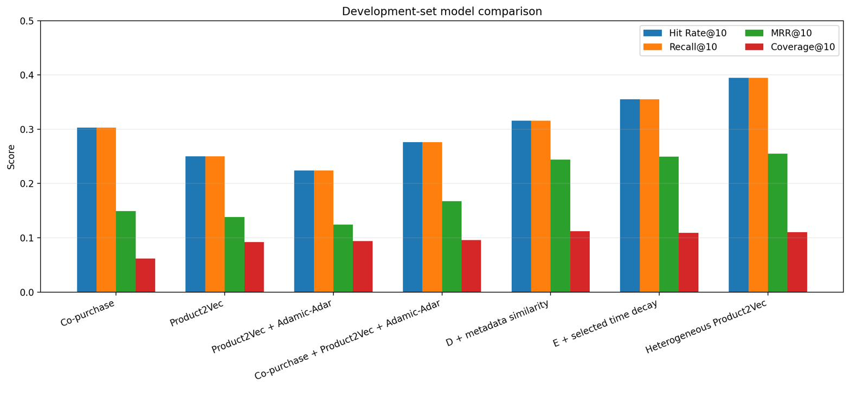
Figure 3. Development ablation across configurations A to G.
The Product2Vec random search reinforced a similar lesson. Larger models did not automatically help. The original 48-dimensional configuration won the expanded 20-candidate search. Available data rather than model capacity is the binding constraint.
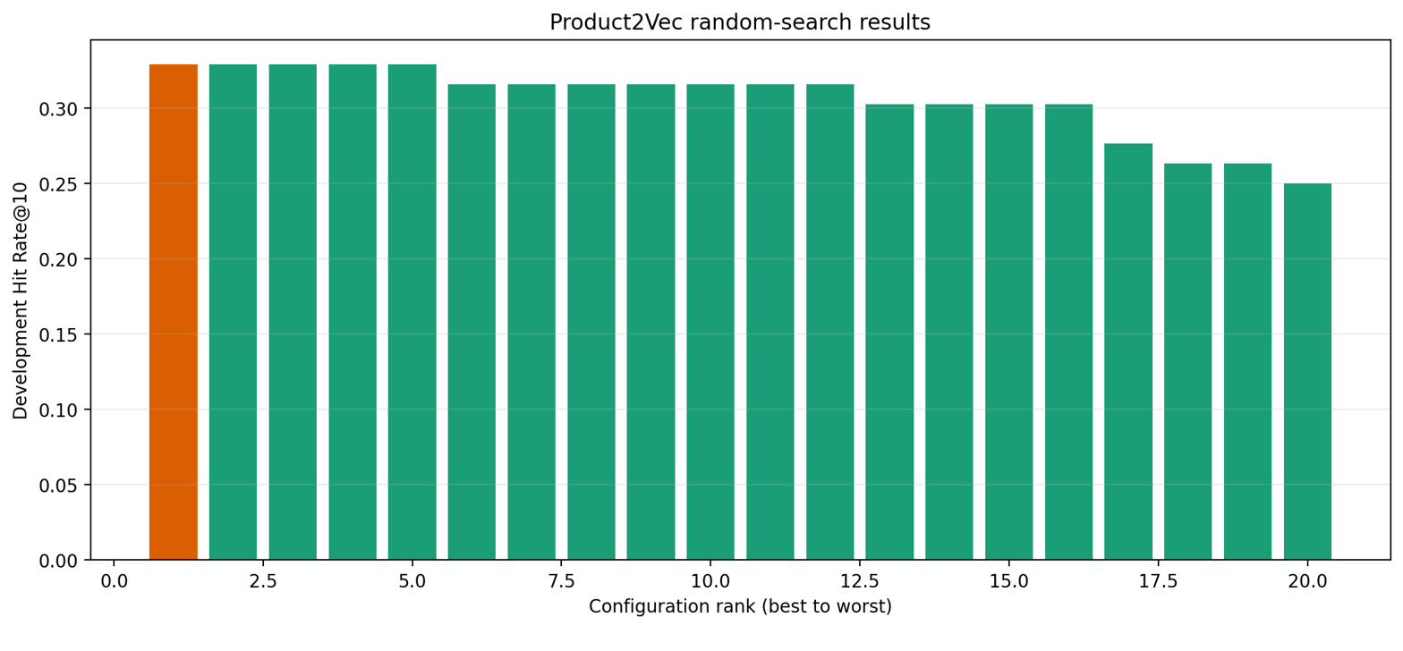
Figure 4. Product2Vec random search over 20 seeded configurations.

4.3 Product-page evaluation
Table 10 reports the stricter single-seed protocol on 76 development queries. The query count matches Table 9 by coincidence, because both protocols filter to the same eligible development orders. The task is not the same. Table 9 supplies the rest of the cart as context, whereas here a single seed product must carry the whole prediction. That is why co-purchase scores 0.303 in Table 9 and 0.237 here. The two columns are not comparable and the lower figure is the harder one.
Model | HR@10 | MRR@10 | Cand. R@100 | Coverage
Global popularity | 0.092 | 0.029 | 0.197 | 0.002
Category popularity | 0.171 | 0.066 | 0.342 | 0.023
Co-purchase | 0.237 | 0.129 | 0.237 | 0.049
Product2Vec | 0.184 | 0.117 | 0.276 | 0.108
Metadata similarity | 0.224 | 0.089 | 0.513 | 0.102
Product-name TF-IDF | 0.316 | 0.177 | 0.474 | 0.106
Historical 40/30/30 hybrid | 0.316 | 0.165 | 0.539 | 0.106
Tuned four-signal hybrid | 0.408 | 0.214 | 0.553 | 0.108
Table 10. Product-page evaluation on 76 development queries.
The most striking result in this table is that TF-IDF over Greek product names alone reaches 0.316, ahead of the entire co-purchase graph at 0.237. A purely linguistic signal computed from nothing but text strings outperform years of accumulated purchase behavior. This measures how little the graph has to work with. It argues for treating product text as a first-class signal in sparse retail settings.
The tuned hybrid retrieves 42 of 76 targets within its first 100 candidates and ranks 31 of them inside the top ten. Compared with the 24 hits of the historical hybrid it gains eight and loses one. The 11 targets that are retrieved but fall below rank ten represent the clearest remaining opportunity, since they constitute a re-ranking problem rather than a retrieval problem.
Because these blend weights were selected on these same queries, this table is selection evidence and not an unbiased performance estimate.

4.4 One-time test result
The frozen configuration was refitted on train plus development and evaluated once on the held-out test split, with results in Table 11.
Model | P@10 | HR and R@10 | MRR@10 | Coverage
Original Product2Vec with Adamic-Adar | 0.029 | 0.293 | 0.112 | 0.068
Selected final model | 0.037 | 0.373 | 0.154 | 0.076
Absolute change | +0.008 | +0.080 | +0.041 | +0.008
Table 11. Single evaluation on the held-out test split of 75 queries.
In absolute terms the selected model places the hidden product in the top ten for 28 of 75 test baskets, against 22 for the earlier behavioral blend, which amounts to six additional successful baskets. MRR rises proportionally more than Hit Rate, indicating that hits land earlier in the list rather than merely appearing somewhere near position ten.
Two caveats belong with this number. It was measured under offline basket completion and must not be presented as click-through or conversion performance. Also, the figure of 0.373 belongs to the behavioral and metadata blend, not to the TF-IDF product-page configuration, which has not yet been validated on a future period.
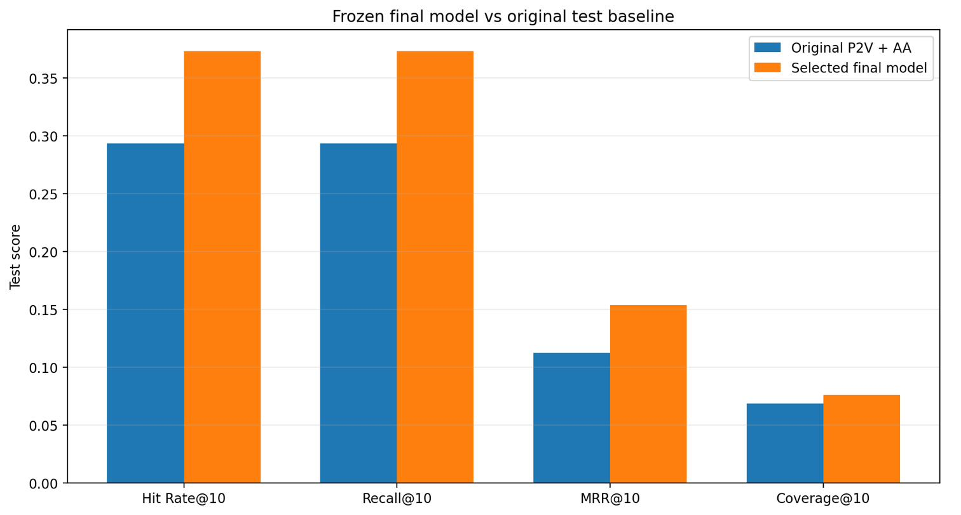
Figure 5. Final test comparison against the original behavioral blend.

4.5 Segment analysis
Aggregate metrics conceal large variation across query types, as Table 12 shows.
Segment type | Segment | Queries | HR@10 | MRR@10
Popularity | Rare | 37 | 0.162 | 0.047
Popularity | Medium | 35 | 0.629 | 0.280
Popularity | Popular | 3 | 0.000 | 0.000
Cart size | Small | 49 | 0.327 | 0.159
Cart size | Medium | 20 | 0.400 | 0.098
Cart size | Large | 6 | 0.667 | 0.292
Table 12. Test performance by target popularity and by cart size.
The popularity gradient is severe. Medium-popularity targets are found almost four times as often as rare ones, at 0.629 against 0.162. Rare targets did improve over the earlier model, rising from 0.108 to 0.162, but they remain the dominant failure mode. The popular segment contains only three queries, so its zero score is noise rather than a finding. We report it only for completeness.
Cart size behaves as intuition predicts, since larger carts express intent more clearly. Performance rises from 0.327 for small carts to 0.667 for large ones. This also serves as a reminder that the system performs worst precisely where it is used most, because small carts are the common case.
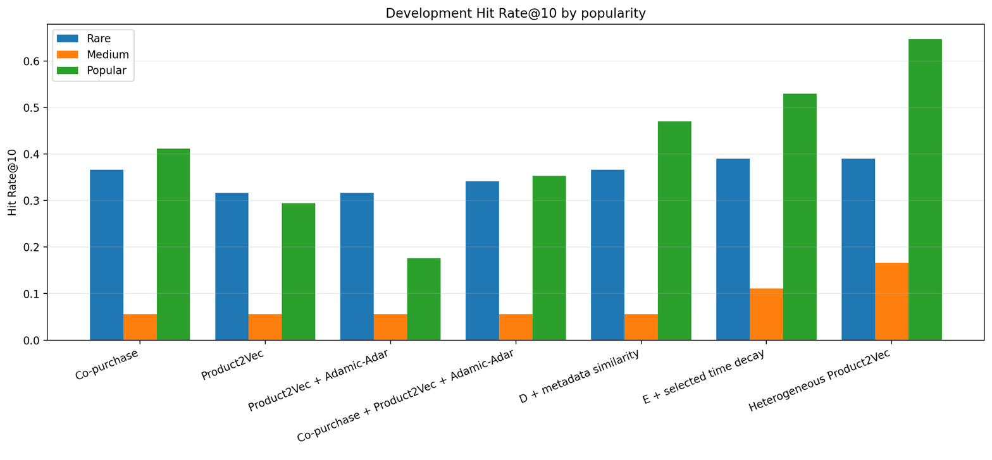 Figure 6. Hit Rate@10 by target popularity segment.

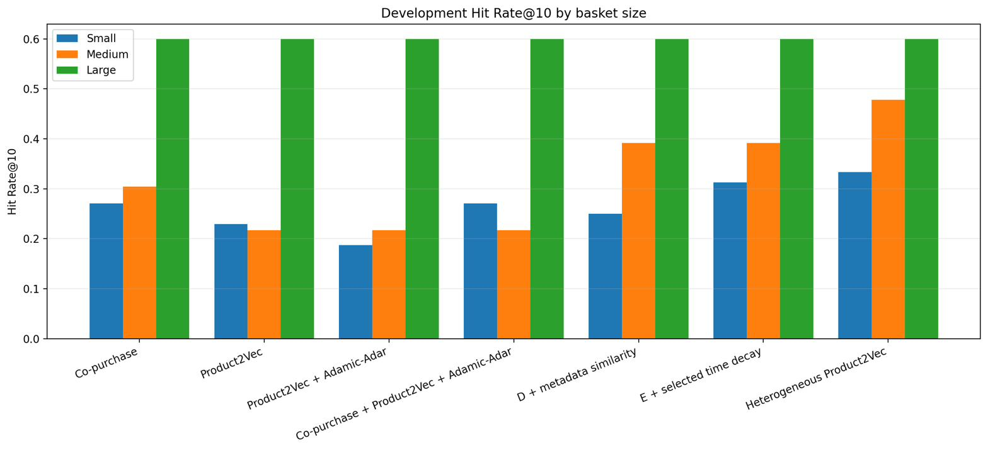
Figure 7. Hit Rate@10 by cart size segment.

4.6 Statistical stability
Table 13 reports bootstrap intervals from 2,000 resamples.
Metric | Point estimate | 95% bootstrap interval
Hit Rate@10 | 0.373 | 0.267 to 0.480
Recall@10 | 0.373 | 0.267 to 0.480
MRR@10 | 0.154 | 0.095 to 0.224
Table 13. Bootstrap confidence intervals from 2,000 resamples over 75 queries.
These intervals are wide and we report them as such deliberately. With 75 independent queries the Hit Rate interval spans more than 20 percentage points. The observed improvement is consistent and directionally supported by the ablation, but this experiment does not establish that the same effect size would hold on a future period or a different assortment. Claiming otherwise would overstate what 75 observations can support.

4.7 Graph visualization
Plotting 6,257 nodes and 8,841 edges produces an unreadable result. We therefore visualize a backbone of the 100 strongest edges together with bounded local neighborhoods. Node size reflects degree and edge width reflects co-purchase weight.
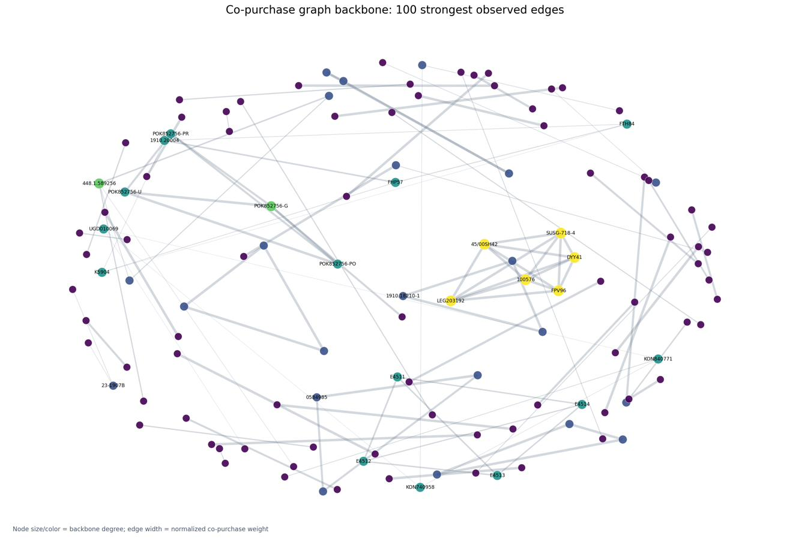 Figure 8. Strongest-edge backbone of the co-purchase graph.

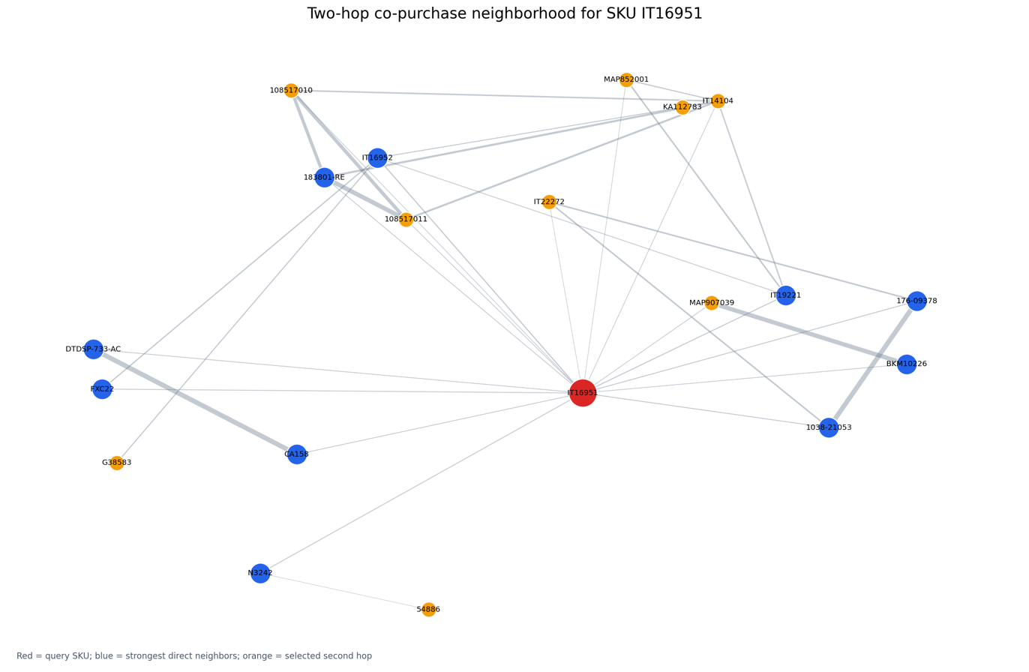
Figure 9. Local neighborhood of SKU IT16951, the most frequently purchased product.

4.8 A negative result on metadata transfer
One further experiment targeted the weakest segment directly. Rare products fail most often precisely because they have too few co-purchase edges, so we built a transfer mechanism that carries complement relationships from well-connected products across to sparse ones using metadata as the bridge. If two products share a category, an age band and a franchise, the argument runs, then the complements of the popular one are plausible complements of the rare one. The bridge used its own field weights, giving category 0.35, age 0.30, hero 0.15, brand 0.10, gender 0.05 and product name 0.05.
Four transfer weights were searched on development data. A weight of 0.1 scored best at 0.237 Hit Rate@10, with performance falling steadily as the transfer grew stronger, down to 0.132 at a weight of 0.4. Already this suggests the mechanism was adding more noise than signal. The frozen weight of 0.2 was then carried to the test split, where the enhanced model reached 0.267 Hit Rate@10 against 0.293 for the base model. On the 90 rare-seed queries that motivated the whole idea, Hit Rate was identical at 0.144 and MRR fell slightly, from 0.064 to 0.061.
The experiment therefore failed, and it is reported here rather than omitted. It failed for an instructive reason. Metadata similarity is already available to the model as a direct scoring channel, where it contributes usefully, as configuration E in Table 9 shows. Using the same weak signal a second time to infer transitive complement relationships compounds its noise instead of adding independent evidence. The lesson is that a signal helping in one role will not necessarily help in another, and that sparse products cannot be rescued by redistributing evidence that does not exist. Reaching them requires genuinely new information, which is the direction Section 6.3 recommends.

5. Qualitative and Error Analysis
Ranking metrics record whether the hidden product was retrieved. They say nothing about whether the other nine recommendations were sensible. We therefore inspected 25 randomly sampled predictions with full catalogue metadata attached.

5.1 Successful patterns
The clearest successes are collection completions. Given a cart containing three Disney Princess mini dolls, the system correctly surfaces further dolls from the same line, placing the hidden Mulan doll at rank nine and leading with Pocahontas. Category, brand and age all align, so the recommendation would be commercially sensible even if that specific hidden item had been missed.
A second pattern is franchise coherence across categories. From a Naruto school bag, the system recommends other Naruto school items such as a pencil case and a lunch container, ranking the hidden Naruto trolley bag second. The category differs from the seed, but the hero attribute carries the association, which is precisely what the metadata channel was introduced to capture.

5.2 Failure patterns
Three failure modes recur across the sample.
Popularity fallback. When the seed product is rare and weakly connected, the model retreats to globally popular items. In one sample case a cart containing an Enchantimals mermaid doll produced a monthly planner as the top recommendation, a mismatch in category, age and intent that reflects the absence of any usable local signal rather than a scoring error.
Category drifts within a plausible neighborhood. A cart of trading-card accessories correctly stays inside the trading-card category but recommends a deck when the hidden target was a card binder. The neighborhood is right and the sub-category is wrong. Across the sample, 52% of top predictions had a category mismatch with the target while only 12% had an age mismatch. The model reliably targets the right age group but frequently the wrong product type.
Cold-start invisibility. Products absent from the training catalogue cannot be recommended at all. Given the seven-year span and the rapid assortment turnover, a substantial share of test-period products are simply unreachable, which caps achievable Hit Rate independently of model quality.

5.3 What the errors imply
The asymmetry between age accuracy at 88% and category accuracy at 48% suggests the metadata weighting does part of its job well and part poorly. Age is nearly complete in the catalogue and generalizes broadly. Category is complete but hierarchical. Our similarity treats the full category path as a single string rather than exploiting its levels. Matching at an intermediate level of the hierarchy is a concrete and low-cost improvement.
Separately, the 11 development targets retrieved to within the top 100 but ranked below ten confirm that retrieval is not the bottleneck for that subset. A learned re-ranker over the existing candidate set could convert them without any change to the underlying signals.

6. Discussion, Comments and Future Work

6.1 Interpretation
The results converge on a single conclusion. On this dataset, data structure constrains performance far more than algorithm choice does. Three independent measurements support it. FP-Growth recovers one frequent pair from seven years of orders. The co-purchase graph has median degree one and leaves a third of the catalogue isolated. And a TF-IDF model over product names, using no behavioral data whatsoever, outperforms the behavioral graph on the product-page task.
This reframes what the project achieved. The gain from 0.293 to 0.373 on test data did not come from a better learning algorithm. It came from finding additional sources of signal in content attributes, product text, recency and attribute-mediated graph paths, all of which compensate for behavioral data that was never dense enough. The lesson generalizes to most small and mid-sized retailers. Before investing in more sophisticated collaborative filtering, check whether there is enough collaboration to filter.
The negative result for Adamic-Adar deserves emphasis, since negative results are informative. It is a well-established method that simply requires denser neighborhoods than this catalogue provides. Reporting it rather than quietly dropping it is part of honest evaluation.

6.2 Limitations
The statistical foundation of the headline number is thin. Only 75 test queries support it, which produces bootstrap intervals spanning over 20 percentage points. A second and subtler issue concerns the product-page configuration. Its four-signal blend was selected on the same 76 development queries on which it is reported, so that table records selection evidence rather than generalization. The configuration has never been validated on a later period.
Offline basket completion is a proxy for the thing we actually care about. It records whether a hidden product appears in the top ten, but it cannot tell us whether a shopper would have clicked or bought anything. Only an online test can answer that. The comparison also assumes the historical assortment continues to resemble the future one, which is a strong assumption in a category where franchises turn over as quickly as toys do.
Scope imposes further limits. No customer identity is modeled at any point, so the system produces item-to-item recommendations rather than personalized ones. Catalogue metadata is inherited from the shop and uneven in quality, with hero missing for 75.9% of products, which caps how much the content channel can contribute. Finally, no product absent from the training period can ever be recommended, so newly introduced items stay invisible until they accumulate purchase history. Given the pace of assortment change, this alone places a ceiling on achievable Hit Rate that no amount of modeling can lift.

6.3 Future work
The most important outstanding task is also the cheapest. The four-signal product-page blend should be validated on a held-out future period without any retuning, which would convert the strongest result in this report from selection evidence into a genuine performance estimate. Until that runs, the figure of 0.408 should be treated as provisional.
Two targeted fixes follow from the error analysis. Exploiting the category hierarchy at intermediate levels rather than treating the full path as a flat string attacks the 52% category-mismatch rate directly, at very low implementation cost. Adding a learned re-ranker over the top 100 candidates addresses a different failure, namely the 11 development targets that the system retrieves but places below rank ten. Neither change requires new data.
Beyond that, the text channel deserves more investment given how well product names already perform. Product descriptions and other catalogue text could extend the current TF-IDF approach towards Greek sentence embeddings, which would capture meaning that character n-grams cannot. A more ambitious step would be to introduce session or view data if the platform can log it, since browsing behavior would relieve the multi-item sparsity constraint at its source rather than compensating for it downstream.
Everything above remains offline. The final step is an online A/B test, which is the only way to convert measured ranking gains into a demonstrated commercial effect.

6.4 Conclusion
We built a complete and locally reproducible recommendation system for a Greek toy retailer, implementing FP-Growth, Node2vec, Skip-Gram with negative sampling and TF-IDF from first principles, then extending them with content and text signals. The final configuration improved test Hit Rate@10 from 0.293 to 0.373 over the initial behavioral model.
The more durable contribution is diagnostic. By measuring sparsity from several independent angles and by reporting a case where a simple text baseline beats a learned graph model, the project shows where effort is best directed on sparse retail data. That direction is towards finding additional signal rather than towards more elaborate models trained on signal that is not there.

7. Members and Roles

Member | Student ID | Responsibilities
Papamanoli Ioanna | F2822510
Sevastou Maria | F2822512
Table 14. Team members and responsibilities.

8. Time Plan
Period | Work package | Deliverable | Status
Week 1 | Problem definition and data audit | Research question, privacy scope and column inventory | Complete
Week 2 | Cleaning and normalization | Reproducible loader and product catalogue | Complete
Week 3 | Market basket analysis | FP-Growth item sets and basket statistics | Complete
Week 4 | Graph construction | Normalized co-purchase graph | Complete
Week 5 | Representation learning | Random walks and Product2Vec embeddings | Complete
Week 6 | Initial evaluation | Chronological splits and baseline metrics | Complete
Week 7 | Hybrid recommendation | Blended engine with Adamic-Adar and metadata | Complete
Week 8 | Error analysis | Segment breakdowns and qualitative samples | Complete
Week 9 | Controlled improvement | Status, graph, decay and embedding search | Complete
Week 10 | Content integration | Metadata similarity and heterogeneous graph | Complete
Week 11 | Final evaluation | Frozen test result, intervals and plots | Complete
Week 12 | Deployment and reporting | Streamlit interface and report | Complete
Week 13 | Text extension | TF-IDF baseline and four-signal blend | Complete
Next | Future-period validation | Confirm TF-IDF blend without retuning | Planned
Table 15. Project schedule.

9. Bibliography
[1] Han, J., Pei, J., & Yin, Y. (2000). Mining frequent patterns without candidate generation. Proceedings of the 2000 ACM SIGMOD International Conference on Management of Data, 1 to 12. https://doi.org/10.1145/335191.335372
[2] Grover, A., & Leskovec, J. (2016). node2vec. Scalable feature learning for networks. Proceedings of the 22nd ACM SIGKDD International Conference on Knowledge Discovery and Data Mining, 855 to 864. https://doi.org/10.1145/2939672.2939754
[3] Mikolov, T., Sutskever, I., Chen, K., Corrado, G., & Dean, J. (2013). Distributed representations of words and phrases and their compositionality. Advances in Neural Information Processing Systems, 26.
[4] Adamic, L. A., & Adar, E. (2003). Friends and neighbors on the Web. Social Networks, 25(3), 211 to 230. https://doi.org/10.1016/S0378-8733(03)00009-1
[5] Herlocker, J. L., Konstan, J. A., Terveen, L. G., & Riedl, J. T. (2004). Evaluating collaborative filtering recommender systems. ACM Transactions on Information Systems, 22(1), 5 to 53. https://doi.org/10.1145/963770.963772
[6] Ricci, F., Rokach, L., & Shapira, B. (Eds.). (2022). Recommender Systems Handbook (3rd ed.). Springer. https://doi.org/10.1007/978-1-0716-2197-4
[7] Efron, B., & Tibshirani, R. J. (1993). An Introduction to the Bootstrap. Chapman and Hall, New York. https://doi.org/10.1007/978-1-4899-4541-9
[8] Salton, G., & Buckley, C. (1988). Term-weighting approaches in automatic text retrieval. Information Processing and Management, 24(5), 513 to 523. https://doi.org/10.1016/0306-4573(88)90021-0

10. Appendices

